 **Dr. AMBEDKAR COLLEGE, DEEKSHABHOOMI, NAGPUR**

**Department of Physics (Session 2024-2025)**

Name of the Programme : **STUDENT MENTORING REPORT (Session-2025)**

Date of the Programme : 03/04/2025

Number of Participants : 40

Hosted by : Dept. of Physics

Resource Person  **:** Dr. A N Wazalwar, Dr. A R Bansod,

Dr. N V Pradnyakar and Dr. P V Wakudkar

**Notice**

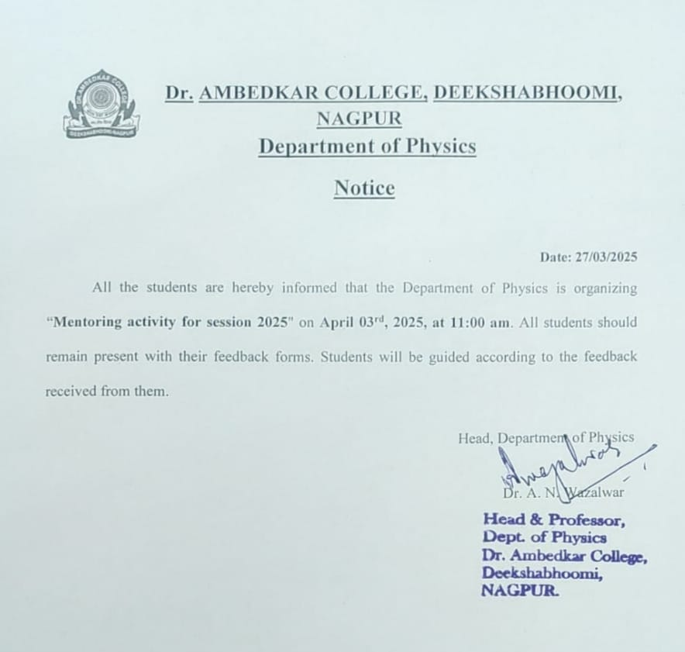

The mentoring activity for the 2024-2025 session was organized on **April 03rd, 2025** for regular students. Dr. A.N. Wazalwar, Head of the Department, along with other faculty members Dr. A.R. Bansod, Dr. Namrata Pradnyakar, and Dr. Pritee Wakudkar were assigned with the students of B.Sc. II and III (PEM and PSM) and B.Sc. 1 (NEP) students.

Forms were generated and feedback was received from the **40** students for whom mentoring activity was conducted. The questionnaire form was designed considering scholastic development, psychological development, personality development and emotional well-being of the students; Students were guided according to the feedback received from students in each session. The analysis was conducted, and feedback was promptly provided to the students. Suggestions and improvement areas were notified to each mentee. All the mentors interacted with the mentees on various problems which were faced by them. Suggestions and improvement regarding each problem were provided to them and timely review was conducted. Progress of each student was recorded and noted down.

Any problem may it be personal or academic was addressed by the faculty members and suggestions were duly given to the students for improvement. Through this activity emotional support was also provided to the students who needed them occasionally. Majorly students face problems due to medical issues, their financial situations and lack of concentration in studies due to overly use of social media. The faculty members tried to solve the problems of the students may it be teaching, learning or stress generated due to their day-to-day life. This year students in first year admitted according the NEP 2020 who has Physics as their major subject. The faculty members briefed the new students on the objectives of NEP 2020, how it can be implemented for undergraduate students, and the structure and requirements of the new education policy. Continuous assessments will be encouraged along with exams, making it necessary for students to maintain good academic performance consistently.

**LIST OF STUDENTS (Mentoring Activity 2025-2026)**

**Teacher’s Name: Dr. Aarti Wazalwar (HOD)**

|  |  |  |  |
| --- | --- | --- | --- |
| **Sr No.** | **Name of the Students** | **Class/Semester** | **Mobile Number** |
| 1 | Archita Bhotmane | Sem IV | 8468999654 |
| 2 | Harsh Wath | Sem VI | 8446233103 |
| 3 | Vinit Panghate | Sem II | 8624964790 |
| 4 | Yash Mankar | Sem II | 9823451999 |
| 5 | Sankalp Patil | Sem II | 9307263079 |
| 6 | Tejswini Pahade | Sem II | 7499479793 |
| 7 | Devi Bisen | Sem II | 9673172652 |
| 8 | Suhani Chikte | Sem II | 9322052915 |
| 9 | Mahakpreet Kaur | Sem II | 9579701711 |
| 10 | Vikas Shukla | Sem II | 8793935323 |
| 11 | Sankalp Patil | Sem II | 9325535994 |

**Photographs:**

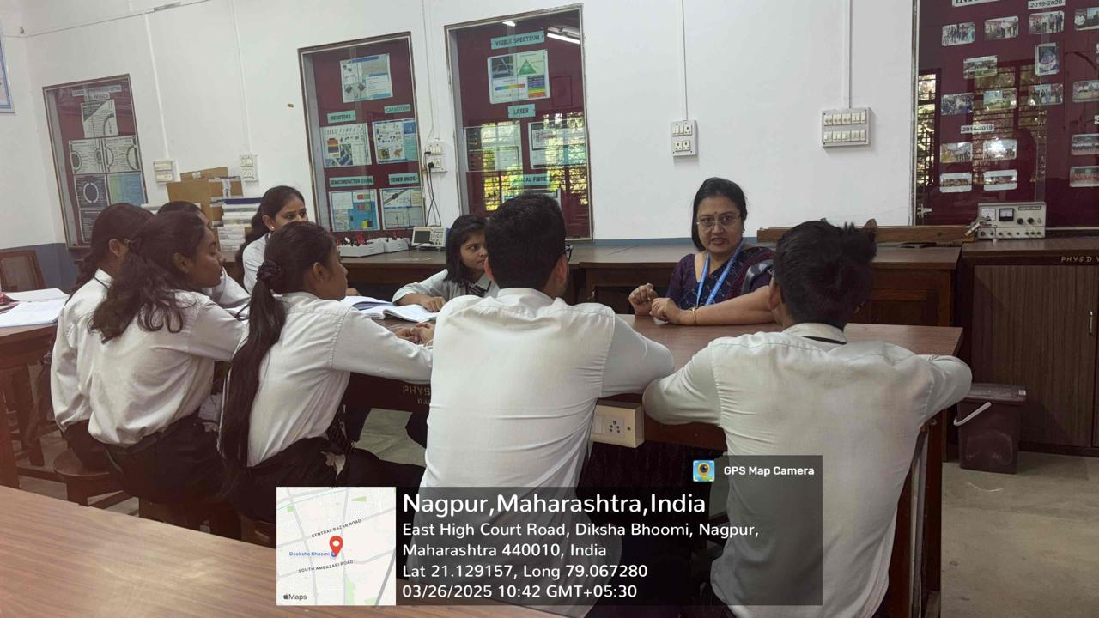 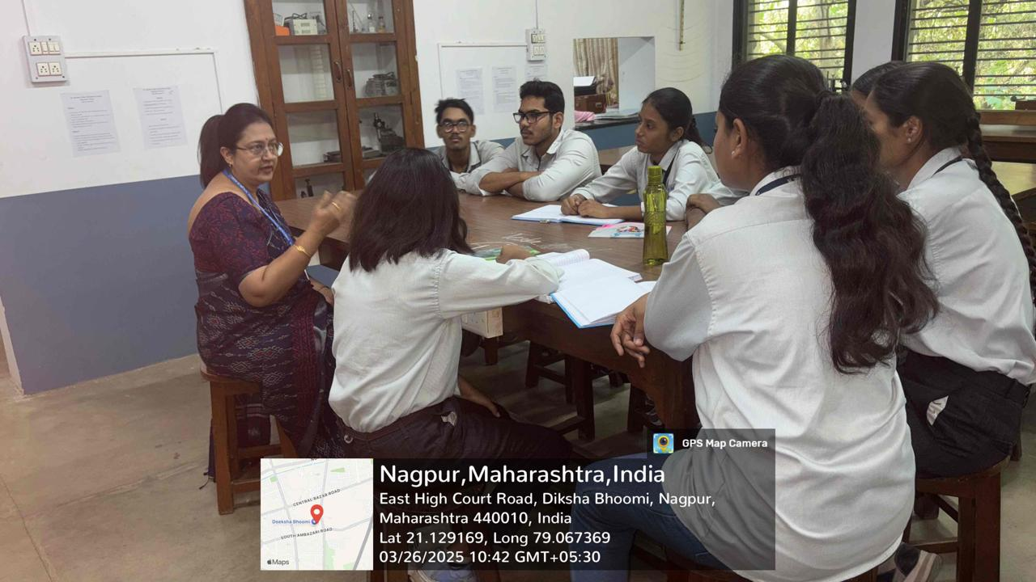

**Mentoring Forms:**

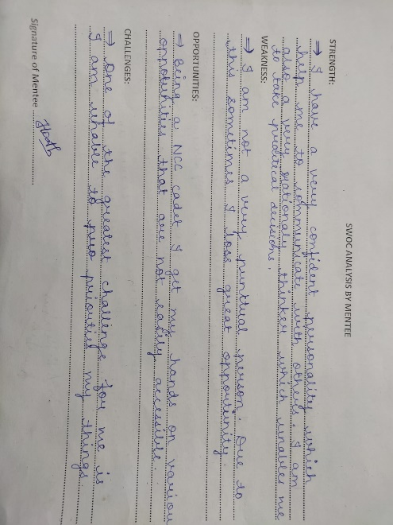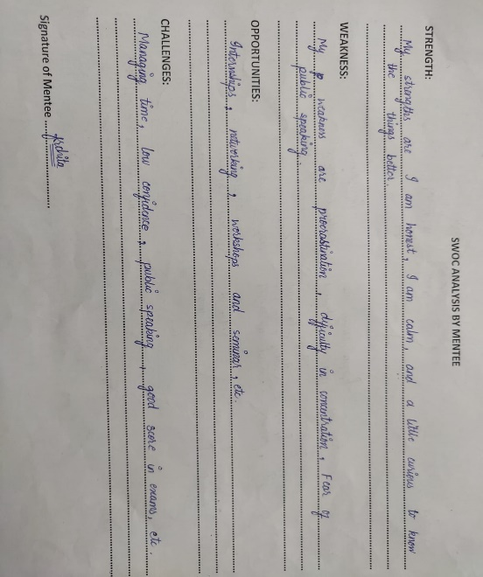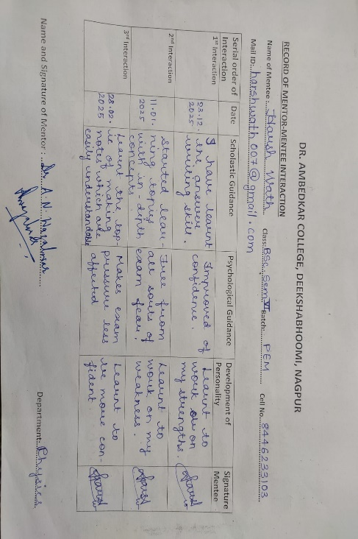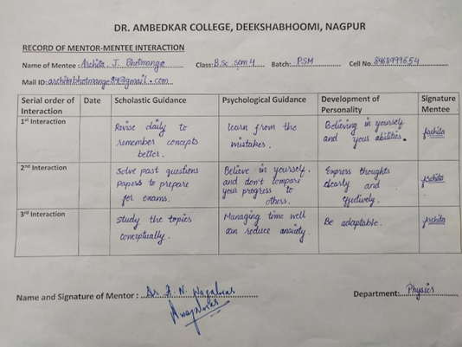

**Teacher’s Name: Dr. Amit Bansod**

|  |  |  |  |
| --- | --- | --- | --- |
| **Sr No.** | **Name of the Students** | **Class/Semester** | **Mobile Number** |
| 1 | Abhay Biswas | Sem VI | 9011415129 |
| 2 | Pranali Tembhare | Sem VI | 8329471509 |
| 3 | Astha Bhoskar | Sem II | 9307263079 |
| 4 | Nidhi Tayde | Sem II | 9699739441 |
| 5 | Nandini Kale | Sem II | 9309368251 |
| 6 | Yashashree Gandham | Sem II | 9028970837 |
| 7 | Diksha Meshram | Sem II | 8407984842 |
| 8 | Sneha Sabare | Sem II | 9420410053 |
| 9 | Rudranand Bharati | Sem II | 8830124673 |
| 10 | Mitali Janbandhu | Sem II | 8028970837 |

**Photographs:**

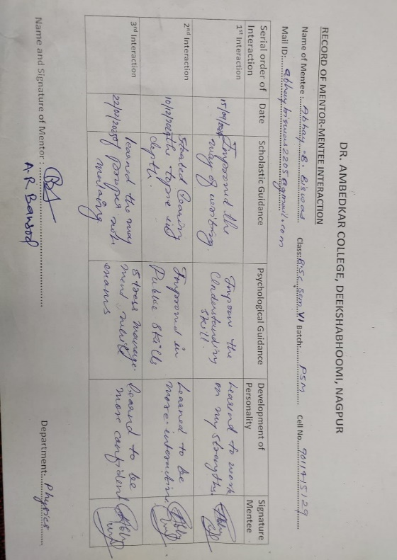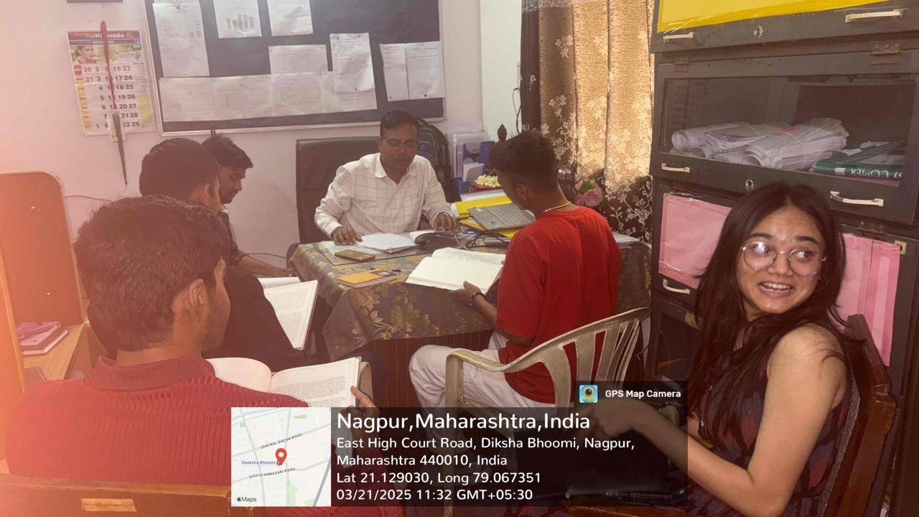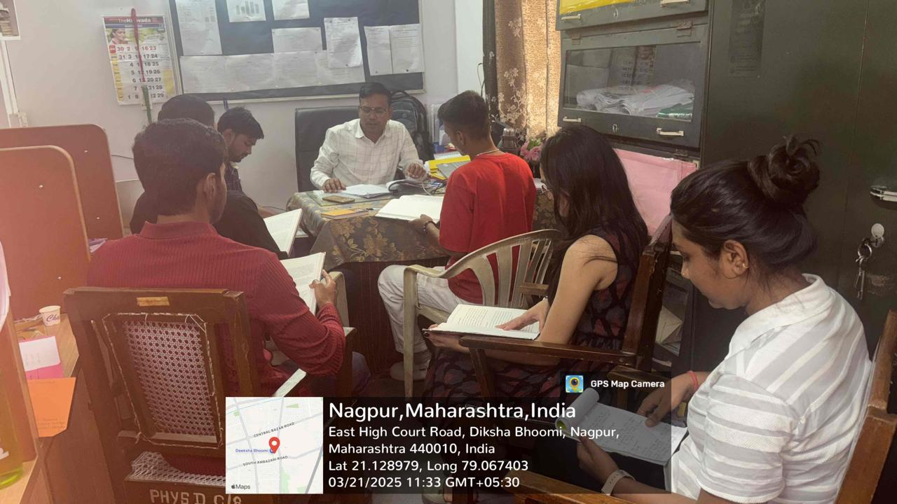

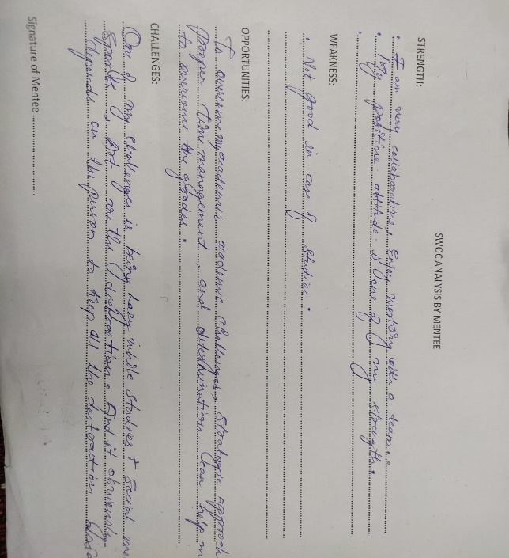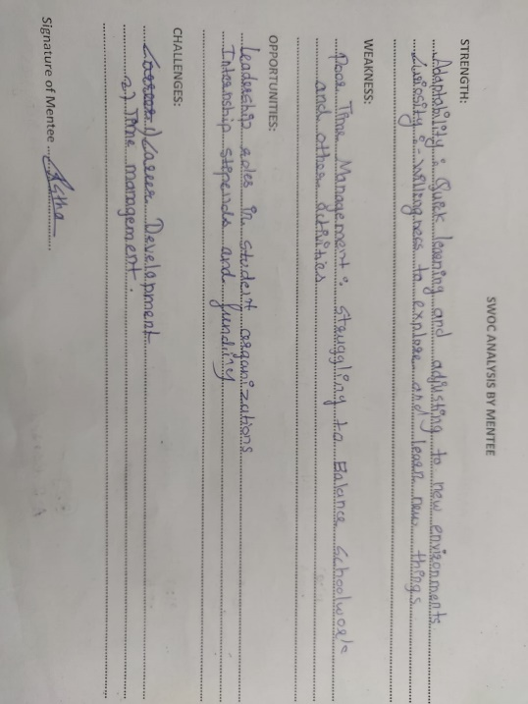**Mentoring Forms:**

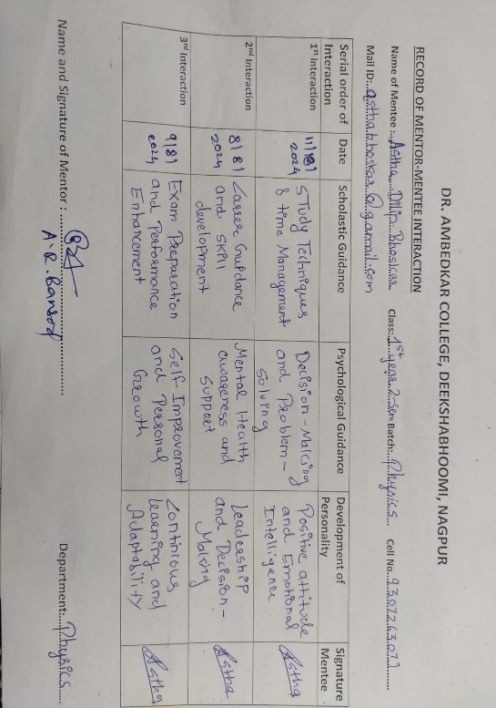

**Teacher’s Name: Dr. Namrata Pradnyakar**

|  |  |  |  |
| --- | --- | --- | --- |
| **Sr No.** | **Name of the Students** | **Class/Semester** | **Mobile Number** |
| 1 | Aryan Chokhandre | Sem VI | 9226507267 |
| 2 | Pratiksha Tembhare | Sem VI | 8767945173 |
| 3 | Sakshi Uikey | Sem II | 9356797650 |
| 4 | Priyal Guddhe | Sem II | 9028514557 |
| 5 | Khushbu Shingru | Sem II | 8767261864 |
| 6 | Parnashree Bhagat | Sem II | 9325065539 |
| 7 | Harshlata Gawate | Sem II | 9823451990 |
| 8 | Anushka Chake | Sem II | 7385278284 |
| 9 | Manasvi Bhatankar | Sem II | 9373645020 |
| 10 | Achal Wasnik | Sem II | 8766087425 |

**Photographs:**

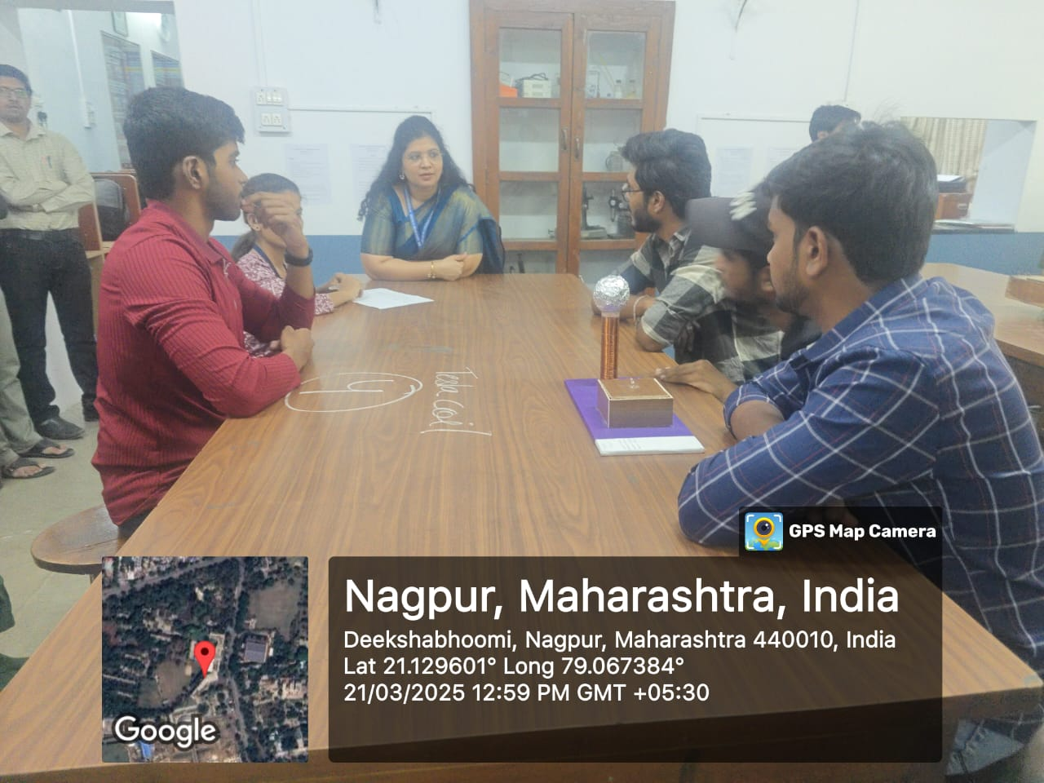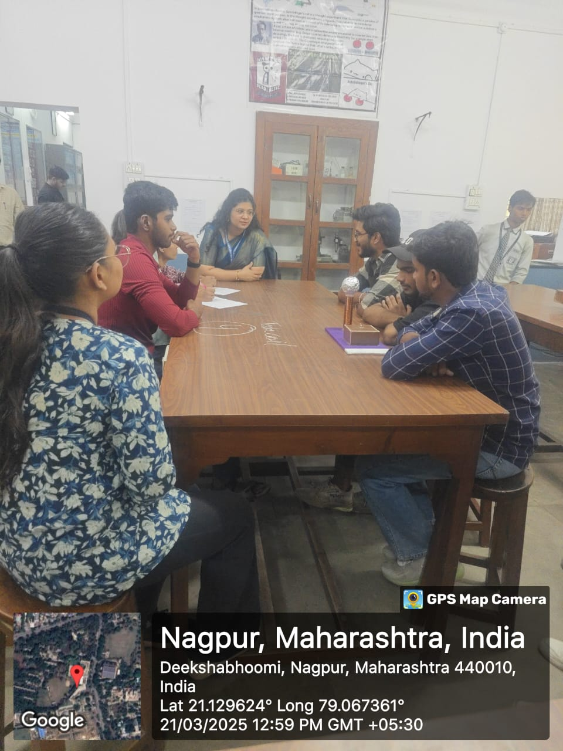

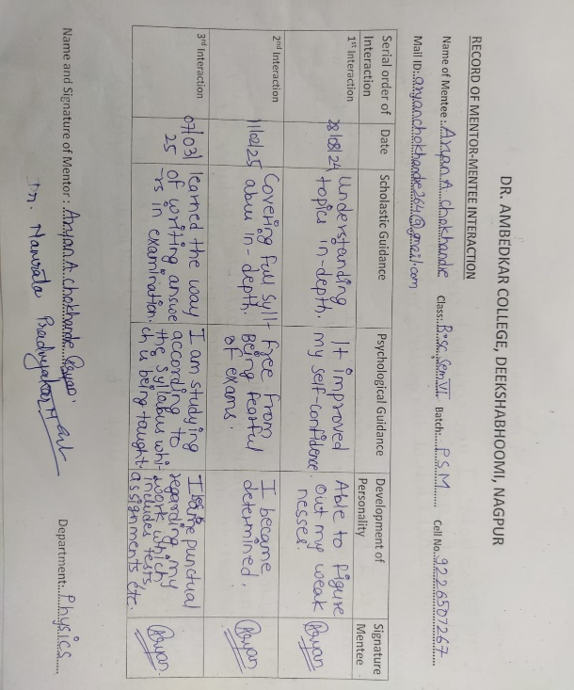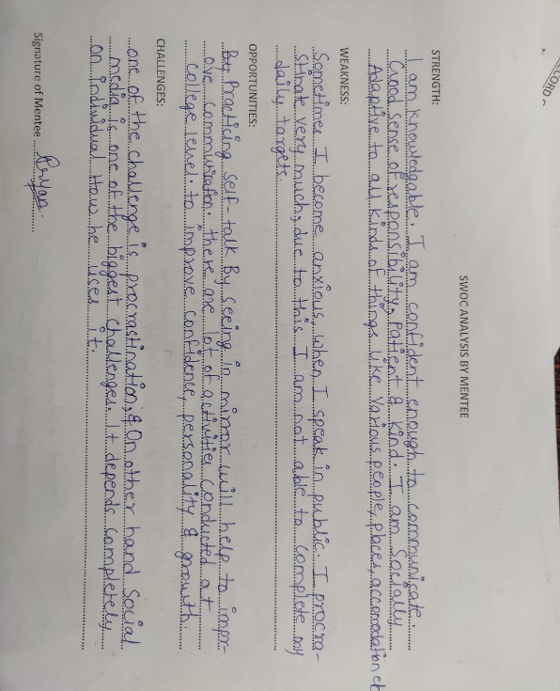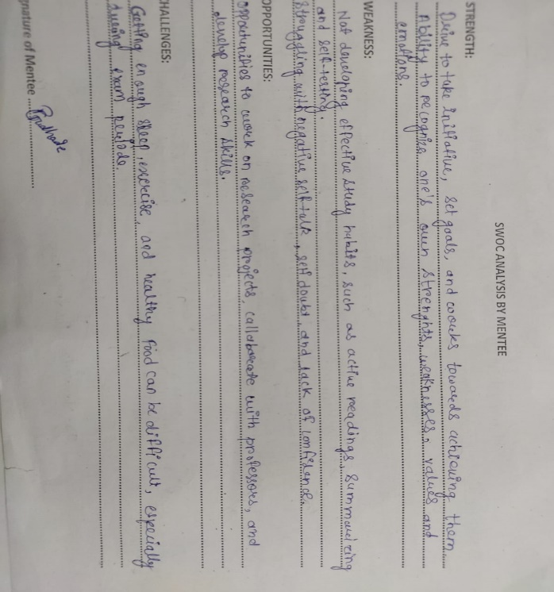**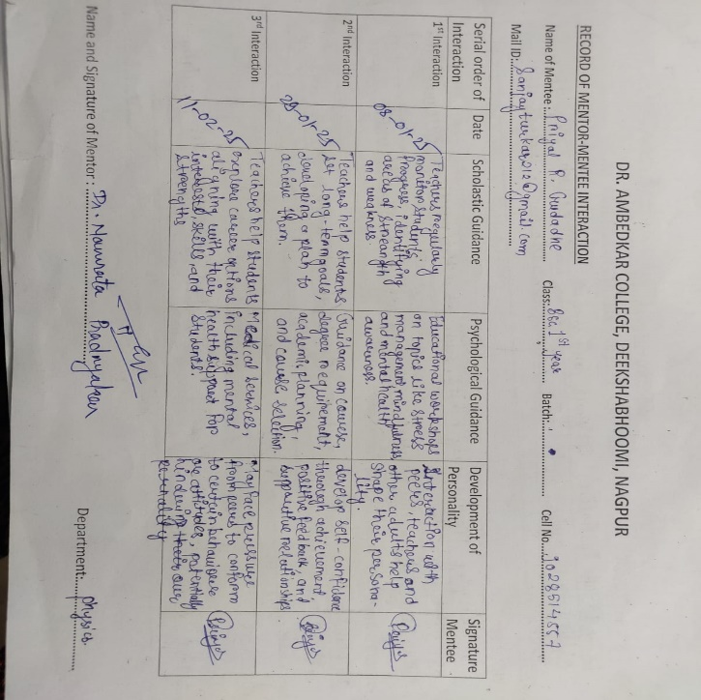Mentoring Forms:**

**Teacher’s Name: Dr. Pritee Wakudkar**

|  |  |  |  |
| --- | --- | --- | --- |
| **Sr No.** | **Name of the Students** | **Class/Semester** | **Mobile Number** |
| 1 | Sujal Kohale | Sem VI | 7043193085 |
| 2 | Mahima Baraskar | Sem VI | 9529053288 |
| 3 | Suhani Gawde | Sem II | 7387574909 |
| 4 | Manvi Garge | Sem II | 8766931689 |
| 5 | Sneha Mandal | Sem II | 8669087739 |
| 6 | Kapil Fulzele | Sem II | 8010264960 |
| 7 | Nitish Kamble | Sem II | 8308290048 |
| 8 | Aryan Farkade | Sem II | 9325923074 |
| 9 | Prajwal Injewar | Sem II | 8010417195 |
| 10 | Sheshkumar Dongre | Sem II | 8261998457 |

**Photographs:**

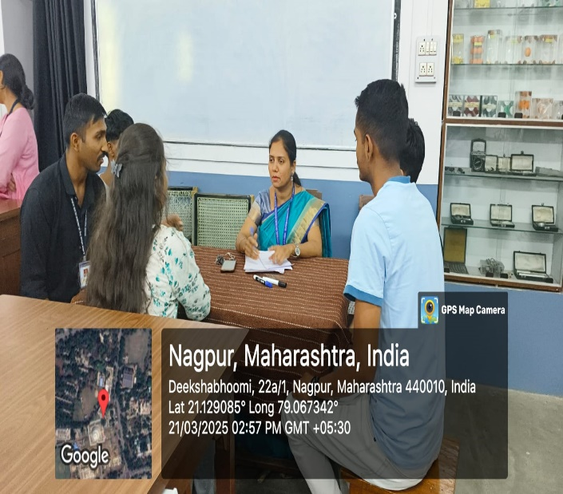 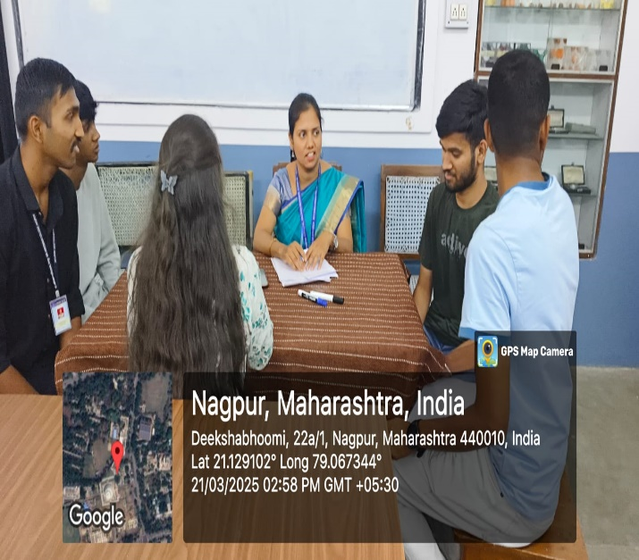

**Mentoring Forms:**

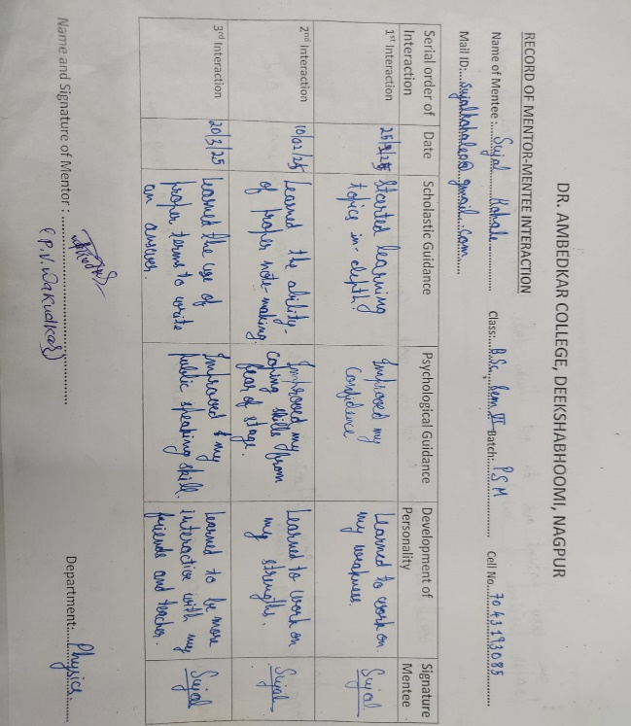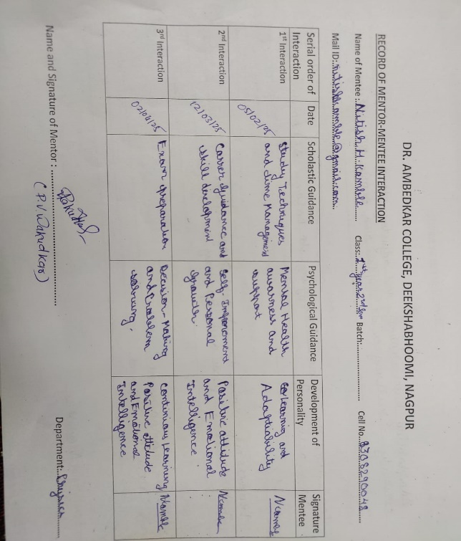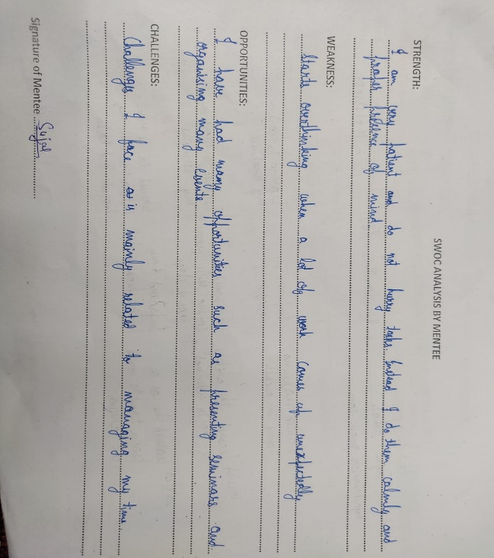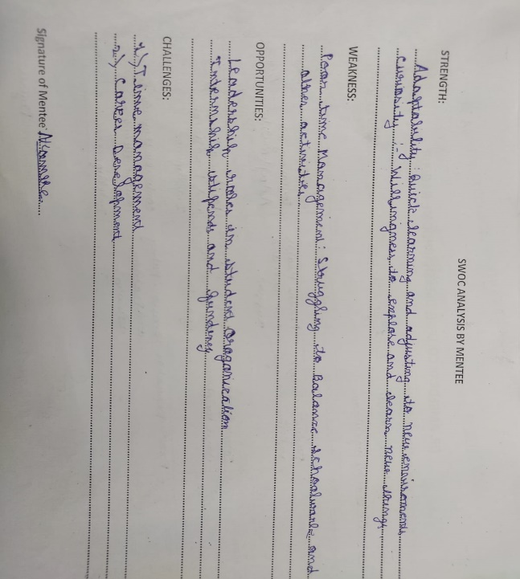

**Head Department**

**Dr. Aarti Wazalwar**

**Professor, Dept. of Department**